**This application consists of a web app and an API that is connected to a database.**

1. Create a folk from this repository.

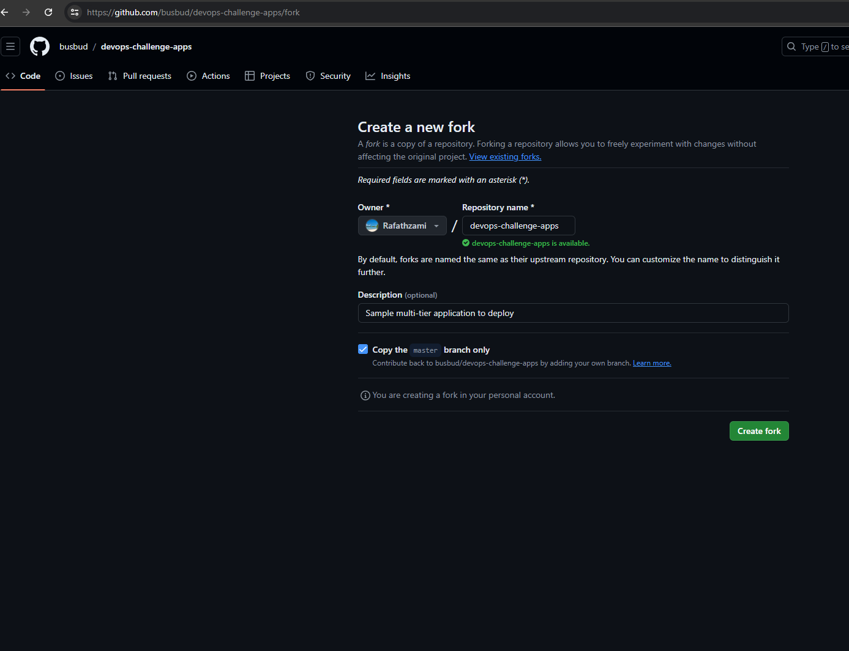

2. Write Docker files for Web app and API.

**# Web app docker file**

**FROM node:16-alpine**

**WORKDIR /app**

**#if we need to copy the build files we can uncomment below**

**#COPY dist/app.js ./**

**#please comment the below line if you're copying from the direct build artifacts**

**COPY package*.json ./**

**RUN npm install**

**COPY . .**

**EXPOSE 5000**

**CMD [ "npm", "start" ]**

**# Api Docker file**

**FROM node:latest**

**WORKDIR /app**

**COPY package*.json ./**

**RUN npm install**

**COPY . .**

**EXPOSE 5000**

**CMD [ "npm", "start" ]**

**3. Identify resources that you need and develop a deployment diagram.**

Resources:

Servers / AZURE VM

Web Server: - Nginx, Apache / Azure App Service, Application Gateway

Application containers: - Docker runtime, Web app & API docker images / Azure Container Registry

Database instance: Postgres / Azure Database for PostgreSQL

CI/CD : Jenkins / Azure Devops

Method 1 :

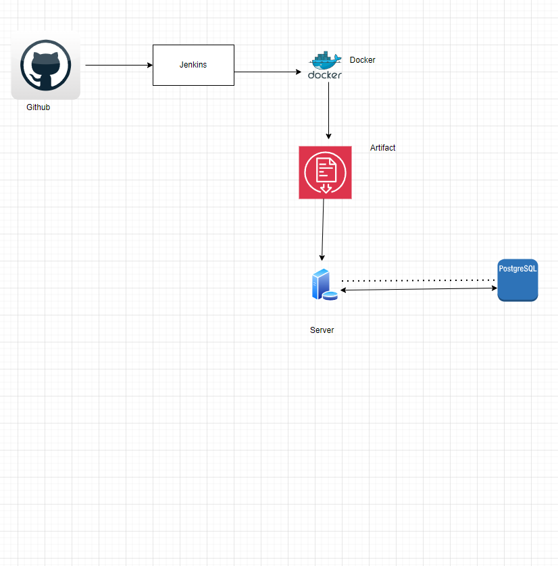

**Method 2 :**

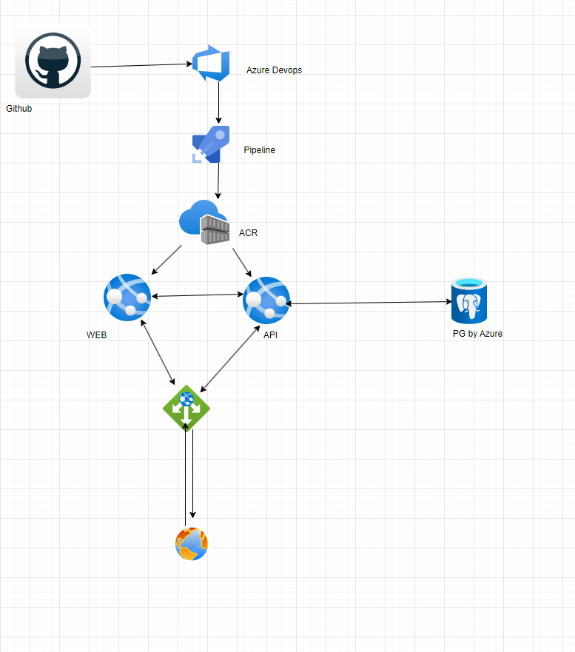

**4. Write the Terraform code to provision the infrastructure on a cloud of your choice.**

**Note : Terraform files are in the Terraform directory**

**5. Deploy Web app and API to the cloud. Make sure that you are using containerized**

**technologies provided in the cloud platform**

1. We using GitHub for version control and Maintain our codes respectively
2. Whenever a change happens into GitHub repos Azure DevOps will trigger a pipeline
3. After that pipelines will build the docker images and Push it to ACR in Azure .
4. And from the pipeline itself we can configure to deploy our containers into App service.
5. We can configure to use database connections from pipelines and we can configure from app service environment variables

6**. Make sure all application components should be appropriately communicated.**

i. DNS Configuration: Make sure Dns is pointed to correct Ip address

ii. Firewall and LB rules: Make sure firewall and LB rules are perfectly enabled so there won’t me any blockages.

iii. Application configs: Need to check the application ports and database, other URLs configured properly

iv. Configure application insights and check the application logs to further troubleshoot or analyze the root cause

**7.Write a CI/CD pipeline using GitHub Actions to automate the deployment process of**

**the Web app and the API**

Files are added to GitHub folder